Clefs: a clef

G-Clefs
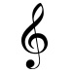
G clef
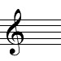
treble clef
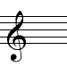
French violin clef

G-Octave Clefs
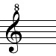
octave treble clef / G octave clef
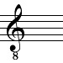
vocal tenor clef
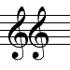
double treble clef

Neutral Clefs
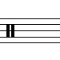
neutral clef
percussion clef
indefinite pitch clef
rhythm clef

gives its name to the line

C-Clefs
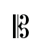
C clef
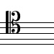
baritone clef
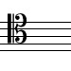
tenor clef
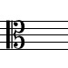
alto clef / viola clef
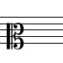
mezzo-soprano clef
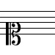
soprano clef

Neutral Clefs
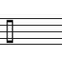
neutral clef
percussion clef
indefinite pitch clef
rhythm clef

it goes around.

F-Clefs
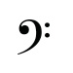
F clef
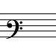
baritone clef
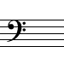
bass clef
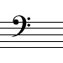
sub-bass clef / contrabass clef

F-Octave Clefs
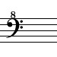
octave bass clef / F octave clef (perform one octave higher)
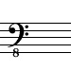
octave bass clef (perform one octave lower)

TAB
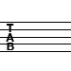
Tab clef

